

**Appropriate Assessment Screening Report**

**for 19 Aquaculture Licences in**

**Killary Harbour, Co. Galway/Mayo.**

**Produced by**

**AQUAFACT International Services Ltd.**

**On behalf of**

**Aquaculture Licences Appeals Board (ALAB)**

**November 2014**

AQUAFACT INTERNATIONAL SERVICES ltd.

12 KILKERRIN PARK,

GALWAY

[**www.aquafact.ie**](http://www.aquafact.ie)

info@aquafact.ie

tel +353 (0) 91 756812

fax +353 (0) 91 756888

Table of Contents

1. Introduction 1

1.1. Requirement for an Article 6 Assessment 1

1.2. The Aim of this Report 1

2. Appropriate Assessment Process 2

2.1. Introduction 2

2.2. Stages 3

2.2.1.Stage 1. Screening for Appropriate Assessment 4

2.2.2.Stage 2. Appropriate Assessment 4

2.2.3.Stage 3. Alternative Solutions 5

2.2.4.Stage 4. Imperative Reasons of Overriding Public Interest (IROPI)/Derogation 5

3. Appropriate Assessment Screening 6

3.1. Description of the Proposal and Local Area Characteristics 6

3.1.1. Description of the Proposal 6

3.1.2. Description of the Receiving Environment 9

3.1.3. Potential Impacts 12

3.2. Identification of Relevant Natura 2000 Sites 12

3.2.1. Natura 2000 Sites within 15km 12

3.3. Assessment of the Likely Effects 19

3.3.1. Likely Effects of the Proposal 19

3.3.2. Impact Assessment 19

3.4. Screening Assessment 22

4. Conclusion 22

5. References 22

**List of Figures**

Figure 2.1: Stages in the AA process (Source: DEHLG, 2009). 4

Figure 3.1: Location of the Licence renewal sites under appeal in Little Killary. 6

Figure 3.2: Location of the Licence renewal sites under appeal in Middle and Outer Killary. 7

Figure 3.4: cSACs and SPAs within 15km of licence sites 14

**List of Tables**

Table 3.1: Area (ha) and projected tonnages of the 19 licences. 7

Table 3.2: Natura 2000 sites, Qualifying Interests, Potential Impacts and Screening Assessment. * denotes priority habitats. 15

# Introduction

## Requirement for an Article 6 Assessment

Rope mussel aquaculture sites in Killary Harbour are adjacent to a number of Natura 2000 sites and/or their Qualifying Interests. Therefore, it is regarded as necessary that this proposal have due regard to Article 6 (3) of the EU Habitats Directive[1] which states:

Article 6 (3): Any plan or project not directly connected with or necessary to the management of the [Natura 2000] site but likely to have a significant effect thereon, either individually or in combination with other plans or projects, shall be subject to appropriate assessment of its implications for the [Natura 2000] site in view of the [Natura 2000] site’s conservation objectives.

This is transposed into national legislation by Regulation 31 of the European Communities (Natural Habitats) Regulations 1997.

## The Aim of this Report

This document has been prepared in accordance with current guidance (DEHLG, 2009, Revised February 2010; EPA Advice Notes on Current Practice (CAAS, 2003); EPA ‘*Guidelines on the Information to be contained in Environmental Impact Statements’* (CAAS, 2002); and the Institute of Ecology and Environmental Management’s Guidelines for Ecological Impact Assessment (IEEM, 2006) and provides an assessment of the ecological impacts of the proposed river crossing.

The document provides the information required in order to establish whether or not the proposed rope mussel aquaculture sites are likely to have a significant impact on surrounding Natura 2000 sites in the context of their conservation objectives and specifically on the habitats and species for which the site has been designated.

# Appropriate Assessment Process

## Introduction

There is a requirement, under Article 6(3) of the EU Habitats Directive (Directive 92/43/EEC), to carry out an Appropriate Assessment. The first step of the Appropriate Assessment process is to establish whether, in relation to a particular plan or project, Appropriate Assessment is required. Article 6(3) states:

‘Any plan or project not directly connected with or necessary to the management of the site but likely to have a significant effect thereon, either individually or in combination with other plans or projects, shall be subject to appropriate assessment of its implications for the site in view of the site’s conservation objectives. In the light of the conclusions of the assessment of the implications for the site and subject to the provisions of paragraph 4, the competent national authorities shall agree to the plan or project only after having ascertained that it will not adversely affect the integrity of the site concerned and, if appropriate, after having obtained the opinion of the general public.’

If the Appropriate Assessment determines that a plan or project may adversely affect the integrity of a Natura 2000 site, then Article 6 (4) may come into play. Article 6 (4) states that:

‘If, in spite of a negative assessment of the implications for the [Natura 2000] site and in the absence of alternative solutions, a plan or project must nevertheless be carried out for imperative reasons of overriding public interest, including those of a social or economic nature, Member States shall take all compensatory measures necessary to ensure that the overall coherence of Natura 2000 is protected. It shall inform the Commission of the compensatory measures adopted’.

This Screening Report has been prepared in accordance with the following guidance documents:

* Appropriate Assessment of Plans and Projects in Ireland - Guidance for Planning Authorities (DEHLG 2009, Revised February 2010)
* EU Guidance document on Article 6(4) of the 'Habitats Directive' 92/43/EEC (EC, 2007);
* Assessment of plans and projects significantly affecting Natura 2000 sites. Methodological guidance on the provisions of Article 6(3) and (4) of the Habitats Directive 92/43/EEC (EC, 2002); and
* Managing Natura 2000 Sites: The provisions of Article 6 of the ‘Habitats’ Directive 92/43/EEC (EC, 2000).

Should a decision be reached to the effect that it cannot be said with sufficient certainty that the proposed activity will not have any significant effect on the Natura 2000 sites, then, as is stated above, it is necessary and appropriate to carry out an appropriate assessment of the implications of the activity for the sites in view of their conservation objectives.

The guidance for Appropriate Assessment (DEHLG, 2009, revised February 2010) states:

“AA is an impact assessment process that fits within the decision-making framework and tests of Articles 6(3) and 6(4) and, for the purposes of this guidance, it comprises two main elements. Firstly a **Natura Impact Statement – i.e. a statement of the likely and possible** **impacts of the plan or project on a Natura 2000 site (abbreviated in the following** **guidance to “NIS”)** must be prepared. This comprises a comprehensive ecological impact assessment of a plan or project; it examines the direct and indirect impacts that the plan or project might have on its own or in combination with other plans and projects, on one or more Natura 2000 sites in view of the sites’ conservation objectives. Secondly, the competent authority carries out the AA, based on the NIS and any other information it may consider necessary. The AA process encompasses all of the processes covered by Article 6(3) of the Habitats Directive, i.e. the screening process, the NIS, the AA by the competent authority, and the record of decisions made by the competent authority at each stage of the process, up to the point at which Article 6(4) may come into play following a determination that a plan or project may adversely affect the integrity of a Natura 2000 site”.

It is the responsibility of the competent authority to make a decision as to whether or not the proposed aquaculture sites in Killary Harbour (both alone and in combination with any other active or planed activity) should be permitted, taking into consideration any potential impact upon the Natura 2000 sites in question.

## Stages

It is stated within the EU guidelines that “where, without any detailedassessment at the screening stage,it can be assumed (because ofthe size or scale of theproject or the characteristics ofthe Natura 2000 site) that significant effects are likely*,* it will be sufficient to movedirectly to the appropriate assessment (Stage Two)rather than complete the screeningassessments explainedbelow.”

The Commission’s methodological guidance (EC, 2002) promotes a four-stage process to complete the AA, and outlines the issues and tests at each stage. An important aspect of the process is that the outcome at each successive stage determines whether a further stage in the process is required.

The four stages are summarised diagrammatically in Figure 2.1 below.

4 stages in order

Figure .: Stages in the AA process (Source: DEHLG, 2009).

### Stage 1. Screening for Appropriate Assessment

Screening is the process that addresses and records the reasoning and conclusions in relation to the first two tests of Article 6(3):

1. whether a plan or project is directly connected to or necessary for the management of the site, and
2. whether a plan or project, alone or in combination with other plans and projects, is likely to have significant effects on a Natura 2000 site in view of its conservation objectives.

If the effects are deemed to be significant, potentially significant, or uncertain, or if the screening process becomes overly complicated, then the process must proceed to Stage 2 (AA). Screening should be undertaken without the inclusion of mitigation, unless potential impacts clearly can be avoided through the modification or redesign of the plan or project, in which case the screening process is repeated on the altered plan. The greatest level of evidence and justification is needed in circumstances where the process ends at the screening stage on grounds of no impact.

### Stage 2. Appropriate Assessment

This stage considers whether the plan or project, alone or in combination with other projects or plans, will have an adverse effect on the integrity of a Natura 2000 site, and includes any mitigation measures necessary to avoid, reduce or offset negative effects. The proponent of the plan or project will be required to submit a **Natura Impact Statement**, *i.e.* the report of a targeted professional scientific examination of the plan or project and the relevant Natura 2000 sites, to identify and characterise any possible implications for the site in view of the site’s conservation objectives, taking account of in combination effects. This should provide information to enable the competent authority to carry out the appropriate assessment. If the assessment is negative, *i.e.* adverse effects on the integrity of a site cannot be excluded, then the process must proceed to Stage 4, or the plan or project should be abandoned. The AA is carried out by the competent authority, and is supported by the NIS.

### Stage 3. Alternative Solutions

This stage examines any alternative solutions or options that could enable the plan or project to proceed without adverse effects on the integrity of a Natura 2000 site. The process must return to Stage 2 as alternatives will require appropriate assessment in order to proceed. Demonstrating that all reasonable alternatives have been considered and assessed, and that the least damaging option has been selected, is necessary to progress to Stage 4.

### Stage 4. Imperative Reasons of Overriding Public Interest (IROPI)/Derogation

Stage 4 is the main derogation process of Article 6(4) which examines whether there are imperative reasons of overriding public interest (IROPI) for allowing a plan or project that will have adverse effects on the integrity of a Natura 2000 site to proceed in cases where it has been established that no less damaging alternative solution exists.

The extra protection measures for Annex I priority habitats come into effect when making the IROPI case[2]. Compensatory measures must be proposed and assessed. The Commission must be informed of the compensatory measures. Compensatory measures must be practical, implementable, likely to succeed, proportionate and enforceable, and they must be approved by the Minister.

# 

# Appropriate Assessment Screening

## Description of the Proposal and Local Area Characteristics

### Description of the Proposal

#### Background

In December 2012, the Minister for Agriculture, Food and the Marine granted the renewal of 33 Aquaculture Licences for the cultivation of mussels using longlines in Killary Harbour. Nineteen of these licences were appealed to the Aquaculture Licences Appeals Board. The locations of these 19 licences can be seen in Figures 3.1 and 3.2 for Inner Killary and Outer and Middle Killary respectively.

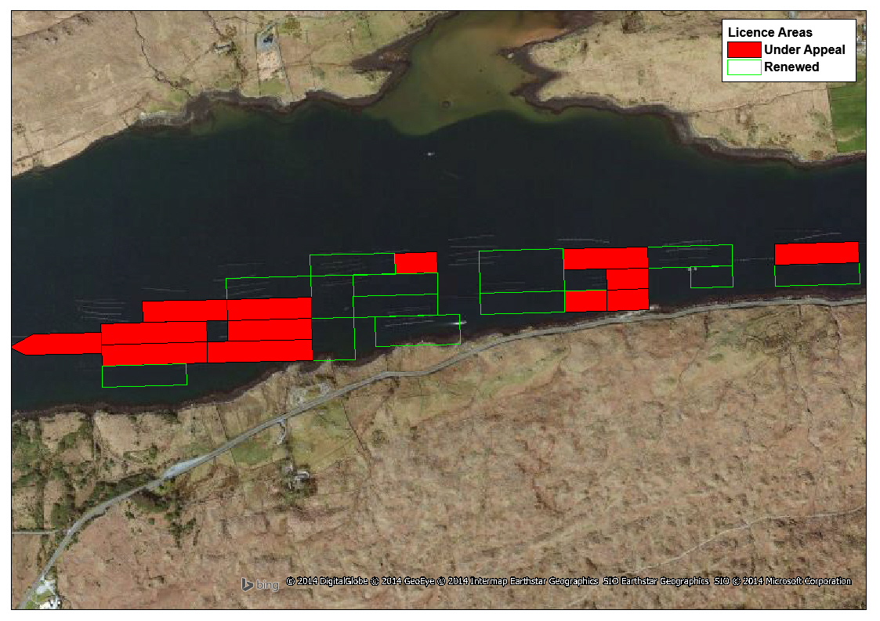

Figure .: Location of the Licence renewal sites under appeal in Inner Harbour.

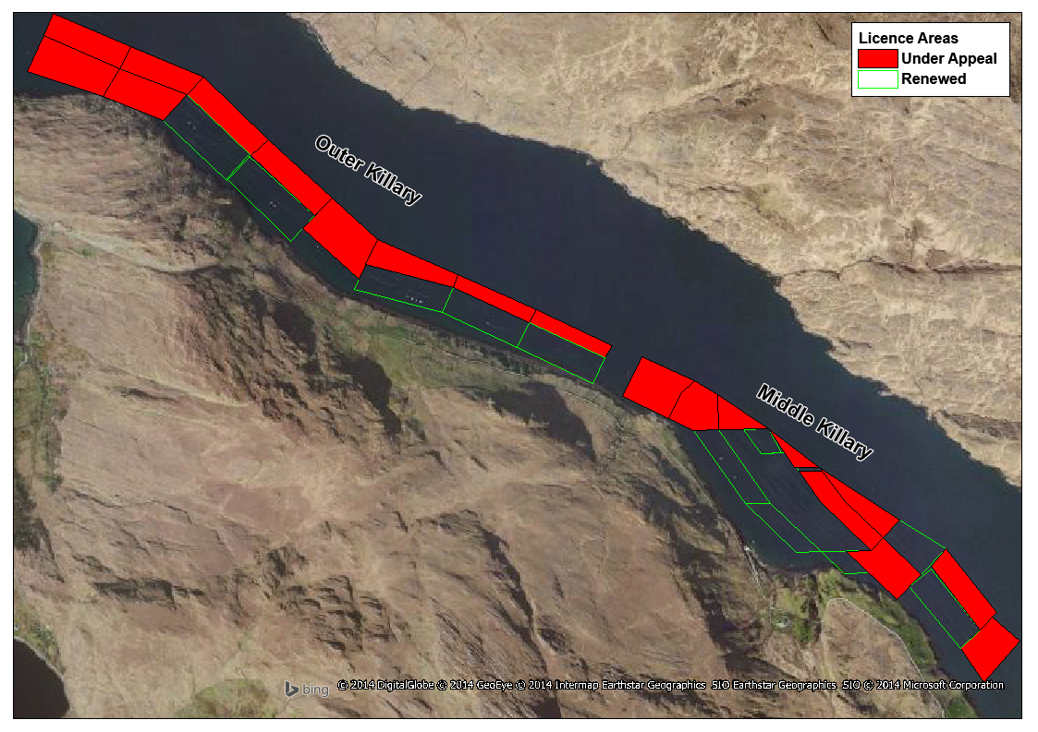

Figure .: Location of the Licence renewal sites under appeal in Middle and Outer Killary.

#### Investigation/development phase

There is no investigation/development phase as the 19 licences are renewals of existing activity.

#### Operational phase

The 19 licences cover an area of 66.29ha. Table 3.1 shows the area covered and projected tonnage from each of the 19 licences.

Table .: Area (ha) and projected tonnages of the 19 licences.

| **Ref. Site No.** | **Area (ha)** | **Projected Tonnage** | | | |
| --- | --- | --- | --- | --- | --- |
| **Yr 1** | **Yr 2** | **Yr 3** | **Yr 4** |
| T9/296 | 3.75 | 25-30 | 25-30 | 25-30 | 25-30 |
| T9/313 | 3.665 | 50 | 50 | 50 | 50 |
| T9/317 | 4.08 | 250 | 250 | 250 | 250 |
| T9/366 | 4.25 |
| T9/385 | 4.2 |
| T9/361 | 4.0 | 10 | 10 | 20 | 30 |
| T9/372 | 4.04 | 60 | 60 | 60 | 60 |
| T9/388 | 3.19 | 20-50 | 20-50 | 20-50 | 20-50 |
| T9/389 | 3.15 | 250 | 250 | 250 | 250 |
| T9/392 | 4.34 |
| T9/399 | 3.3 |
| T9/408 | 2.2 |
| T9/391 | 3.5 | 20 | 30 | 40 | 50 |
| T9/394 | 3.2 | 40-60 | 40-60 | 40-60 | 40-60 |
| T9/397 | 4.625 | 44 | 48 | 52 | 60 |
| T9/398A | 3.0 | 0 | 20 | 20 | 30 |
| T9/400 | 3.0 | 40 | 40 | 40 | 40 |
| T9/401 | 4.3 | 60 | 60 | 60 | 60 |
| T9/422 | 0.5 | 2 | Seed | Seed | seed |

Mussel farming in Killary Harbour is described in the Killary CLAMS report (CLAMS, 2002) and is summarised below.

In early April, farmers in Killary begin checking the water column for the presence of mussel larvae. The larvae are collected by means of plankton nets or pumping water through a sieve. The contents of the sieve or net are then washed into a container and preserved. The samples are then checked under a microscope for the presence of mussel larvae. The growth of the larvae in the water is monitored on a weekly basis as they develop from an early or D-shape stage to a pre-settlement or Eye Spot stage. This whole process takes 4-6 weeks and depends on temperature and food availability. Various methods are employed in Killary for seed collection. Prior to settlement (usually May-early June) farmers deploy material that will provide a surface for the spat or seed to collect on – *i.e.* hairy rope, pergolari and rope, black collector mesh, old fishing net mesh with rope *etc*. Traditionally, the collecting of spat mainly occurs in Inner Killary where the greatest numbers of larvae are concentrated. If settlement is poor in May and June, farmers usually attempt to collect sufficient seed from a later second settlement that usually occurs in August – September. Each year’s mussel spat fall is different. In the past if the spat fall is poor, producers have bought in rock seed from Co. Mayo or Co. Clare. While most of the seed collected is in Inner Killary, in recent years some producers have collected in Outer Killary as spat fall was good there. Typically from August to December farmers uncoil and transfer the collectors from Inner to Middle and Outer Killary.

In July the following year, the droppers can be thinned and the excess mussels are sometimes repacked in a biodegradable cotton mesh sock (pergolari), which is then hung on the longline. Longlines (of 100 to 150m length) with double head rope are suspended from specially made plastic barrels. The plastic barrels have a floatation volume of 210, 300 or 400 litres. It has been proposed, as a condition of the current license renewals, to limit the floatation volume in Killary Harbour to 18,000 litres per hectare. A heavy re-useable dropper rope (8m in length) with the mussels attached is suspended from the double head rope. The reduction in floatation would, in addition to reducing stocking density, decrease the incidence of drop off whereby mussels are lost from the lines due to excessive agitation of droppers in rough weather.

Each producer in Killary may employ different methods of thinning. Some thin the seed collectors by hand ­– *i.e.* take mussels off droppers thereby thinning and then they either repack the thinned-off seed (or half-grown mussels) into pergolari and rehang on the same longline or at another site in the harbour. If a producer has too much seed, he may just discard the thinned stock. Thinning usually takes place only once. If the seed collection is poor one year or if seed has fallen off the dropper, then thinning is sometimes not carried out. Additionally some producers completely strip the dropper of seed then grade and repack them into pergolari. If thinning of seed mussels is not carried out, the mortality can be over 85% as the ropes can only hold a certain amount or biomass of mussels. This can be even higher in heavy settlement years. The stocking density and mortality of mussels is one of the biggest factors affecting growth rate and production in the harbour (Dallaghan & O’Carroll, 2010). The practice of thinning decreases the mortality and competition for food, increases production and shortens the production cycle which in turn increases the quality of the product as there is less fouling on the shells.

In Killary Harbour, a number of the licensed sites are split in two, with one site being in Inner Killary and the second site in Middle or Outer Killary. Licences were designated in this manner as Inner Killary is best suited for the collection of mussel seed which is then transferred to Middle and Outer Killary for ongrowing.

Before the increase in stocking density as a result of the issuing of new licences in 1999/2000, mussels settled during the May-June period (1st Settlement) took typically 18-20 months to reach market size while those settled out in August-September (2nd Settlement) usually took 24 months to attain a similar size. Growing time to market size in Killary in the current licensing regime can now take up to 36 months in some of the areas surrounded by other farms.

### Description of the Receiving Environment

As can be seen in Figures 3.1 and 3.2, the 19 aquaculture sites extend from Inner Killary to Outer Killary.Killary Harbour is a fjörd-like inlet situated between the county boundaries of Mayo to the north and Galway to the south. It is approximately 15km long and 0.75km wide with an average depth of 15m and an average volume of 4.5 x 109m3. A maximum depth of 45m has been recorded at the mouth, which opens out onto the Atlantic Ocean. From the west, the harbour initially runs in a south-easterly direction until it reaches the dogleg or turn, which is located halfway along its overall length, after which it then proceeds in an easterly direction. Its floor has very few rocky outcrops and the main sediment is of soft/fine mud that contains a high organic content.

The catchment area of Killary Harbour is approximately 250km2 and has an extreme Atlantic climate with predominantly S.W. winds and a high rainfall (2000 to 2800 mm year-1). As high mountainous ground surrounds the water body, freshwater runoff is a significant factor in its hydrography. The average freshwater input to the system is 6.0 m3s-1. Around 90% of this input is contributed by the Bundorragha and Erriff on the Mayo side of the harbour and the Bunowen River on the Galway side. Many streams also discharge into the inlet which account for the remainder of the freshwater input. As a result, both coastal and brackish estuarine water conditions are found with the water column being stratified or partially mixed and a pronounced halocline can occur between 3 and 10m depths during winter and summer. The halocline is more evident in the Inner Killary; however, it can be quickly broken up when strong winds occur. There is a mean net flow of water out of the harbour, the net flow at the mouth being equal to the freshwater input. Killary Harbour is largely sheltered from wind and wave action making it an ideal area for aquaculture. Predominant prevailing south-westerly winds usually attain wind speeds of force 4-6 for most of the year; however, the surrounding hills and mountains provide shelter thus reducing the force and direction of these winds. The tidal range is 3.7m with currents strongest at the narrow mouth of the inlet with velocities of 50 and 30cm s-1 being attained at depths of 1 and 10m respectively. Hartnett *et al.* (2011) applied a numerical model to 9 Irish bays and estuaries in order to determine basin-averaged residence times and found that in Killary Harbour the residence time was up to 60 days. The system is a net sink of phytoplankton which is imported from the catchment and ocean boundaries. Mussels feed by filter-feeding phytoplankton and other suspended particulate matter from the water column. Results from models on circulation in the harbour (Nunes *et al.,* 2011) suggest a pattern whereby phytoplankton is imported from the ocean by a subsurface boundary, moving upwards into the system and then being exported back to the ocean at the surface. The harbour has relatively uniform current speeds and directions throughout the outer western half due to its relatively even depth and shape. This pattern changes in the inner harbour where currents are variable in both direction and speed due to shallower depths, a back-up of tidal water and stronger influence of freshwater runoff (Costelloe *et al.,* 1998).

The area of Killary Harbour that the aquaculture licences occur in is not designated as cSAC or SPA but it does contain two Annex I habitats: Large shallow inlet and bays (1160) and Reefs (1170). AQUAFACT carried out a benthic survey of Killary Harbour in 2012 for the Marine Institute, EPA and DECLG for the Water Framework Directive (AQUAFACT, 2012). This survey revealed that sand dominated Killary Harbour with variations in the quantity of mud and gravel throughout. According to the Folk (1954) classification gravelly muddy sand, slightly gravelly muddy sand, sand, slightly gravelly sand and muddy sand were all present in Killary Harbour. The stations in Killary Harbour were dominated by a variety of species: the molluscs *Kurtiella bidentata,* *Thyasira flexuosa, Myrtea spinifera* and *Turritella communis*, the annelids *Dipolydora quadrilobata,* *Melinna palmata, Euclymene oerstedii, Tubificoides swirencoides, Magelona minuta, Notomastus latericeus,* *Leitoscoloplos mammosus, Diplocirrus glaucus, Paradoneis lyra* and *Chaetozone christiei,* the crustacean *Metaphoxus pectinatus* and the sipunculid worm *Phascolion (Phascolion) strombus strombus.* All species are commonly found in similar sandy/muddy environments around the county.

Approximately 3.2km to the northeast of the inner most aquaculture licence site lies the boundary to the Mweelrea/Sheeffry/Erriff Complex cSAC (IE001932). The Mweelrea/Sheeffry/Erriff Complex cSAC does not contain any marine or coastal habitats that are Qualifying Interests. This inner section of Killary Harbour does contain the Annex I habitat Estuaries (1130). The Mweelrea/Sheeffry/Erriff Complex cSAC does contain a number of coastal species that are Qualifying Interests of the cSAC: the otter *Lutra lutra* and Atlantic salmon *Salmo salar.* The Freshwater pearl mussel *Margaritifera margaritifera* is confined to freshwater but its lifecycle does depend on salmon.

In addition to the above mentioned Annex I habitats and Annex II species, the following Annex II species also occur in the harbour and in the vicinity of the aquaculture sites: bottlenose dolphins *Tursiops truncatus,* grey seals *Haliochoerus grypus* andharbour seals *Phoca vitulina.*

Bottlenose dolphins are frequently sighted between Killary Harbour and Mannin Bay and also extending into the upper reaches of Killary Harbour. A study of bottlenose dolphins in the area (Ingram *et al*., 2009) concluded that Connemara is clearly used by a large number of animals and the estimate exceeds all previous estimates of the number of bottlenose dolphins using the lower Shannon SAC. The West Connacht Coast cSAC (IE002998) is located *c.* 2.8km to the west of the aquaculture sites and the bottlenose dolphin is a Qualifying Interest of this cSAC.

Inishshark and Inishgort are two import breeding sites for grey seals in the area. Both islands are located to the southwest of Inishbofin. Other records include Killary Harbour and Inishbofin. The nearby Inishbofin and Inishshark cSAC (IE000278) is designated for grey seals. A number of the islands outside of Killary Harbour are moulting sites for grey seals (Glassillaun, Inishgort, Inishshark, Inishskinnymore, Inishskinnybeg, Davillaun and Caher Isl.) (O’Cadhla & Strong, 2007). Harbour seals are recorded from Mannin Bay, Ballinakill Harbour and Roonagh Quay, Co. Mayo and the closest cSAC for harbour seals is Clew Bay Complex (IE001482).

### Potential Impacts

The potential impacts associated with rope mussel culture are:

* Current alteration – a baffling effect which results in a slowing of currents and increasing deposition onto the seabed changing the sedimentary composition.
* Organic enrichment – Faecal and pseudofaecal deposition on the seabed which could potentially alter community composition.
* Shading – The prevention of light penetrating to the seabed which could potentially impact light sensitive species
* Fouling – Increased secondary production on structures and culture species and increased nekton production
* Seston filtration – The alteration of phytoplankton and zooplankton communities and potential impacts on carrying capacity
* Nutrient exchange – Changes in ammonium and dissolved inorganic nitrogen resulting in increased primary production and nitrogen removal at harvest.
* Alien species – Introduction of non-native species with culture organism transported into the site.

## Identification of Relevant Natura 2000 Sites

### Natura 2000 Sites within 15km

Figure 3.4 shows the cSACs and SPAs within 15km of the aquaculture sites. Table 3.2 details the qualifying interests of each of the Natura 2000 sites and identifies those of relevance to the proposed aquaculture activity (*i.e.* screened in). Those that are not relevant to the proposed aquaculture activity and are screened out are done so on the basis of distance from the aquaculture sites and therefore cannot be impacted or due to the fact that they are non-marine habitats or species and therefore cannot be impacted by the proposed aquaculture. The resulting Qualifying Interests that are screened in are as follows:

* Salmon *Salmo salar* (Mweelrea/Sheeffry/Erriff Complex cSAC IE001932, The Maumturk Complex cSAC IE002008, Twelve Bens/Garraun Complex cSAC IE002031)
* Otter *Lutra lutra* (Mweelrea/Sheeffry/Erriff Complex cSAC IE001932 and Twelve Bens/Garraun Complex cSAC IE002031)
* Bottlenose dolphin *Tursiops truncatus* (West Connaught Coast cSAC IE002998)

In addition to the above, there are cSACs for the grey seal *Halichoerus grypus* and harbour seal *Phoca vitulina* in relatively close proximity to Killary Harbour given the foraging range of these species. The closest cSAC for the grey seal is the Inishbofin and Inishshark cSAC (IE000278) and the closest cSAC for the Harbour seal is Clew Bay Complex (IE001482). The impacts on these species will also be assessed.

The Conservation Objectives of these Natura 2000 Sites are discussed below in Section 3.3 in the context of the impacts of the proposed activity on them.

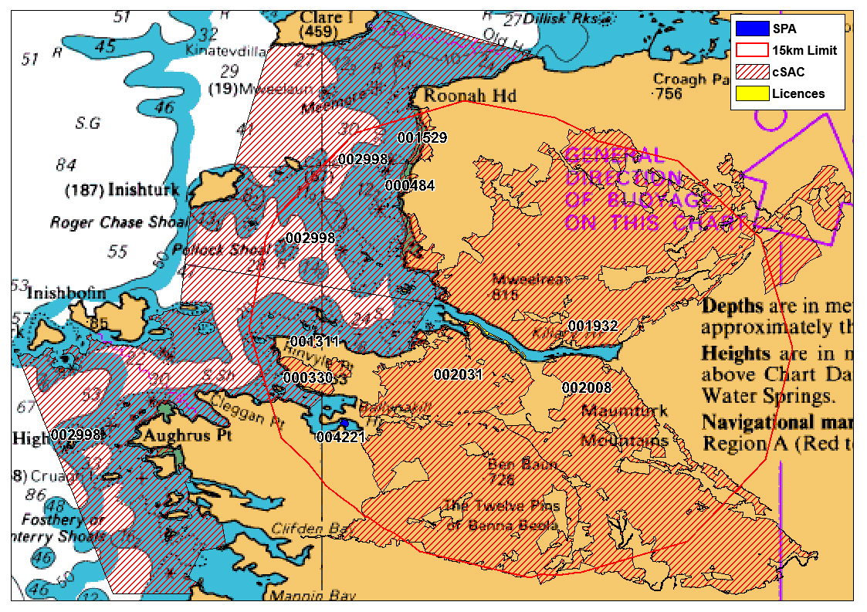

Figure .: cSACs and SPAs within 15km of licence sites

Table .: Natura 2000 sites, Qualifying Interests, Potential Impacts and Screening Assessment. * denotes priority habitats.

| **Natura 2000 Site** | **Site Code** | **Qualifying Interests** | **Potential Impacts** | **Screening Assessment** |
| --- | --- | --- | --- | --- |
| Mweelrea/Sheeffry/Erriff Complex cSAC | IE001932 | [1013] *Vertigo geyeri* | No Spatial overlap | Screened Out |
| [1014] *Vertigo angusitor* | No Spatial overlap | Screened Out |
| [1029] Freshwater pearl mussel *Margaritifera margaritifera* | No Spatial overlap | Screened Out |
| [1106] Salmon *Salmo salar* (only in freshwater) | Migrating salmon passing through Killary Harbour could interact with mussel aquaculture activities | Screened In |
| [1150] Coastal lagoons* | No Spatial overlap | Screened Out |
| [1210] Annual vegetation of drift lines | No Spatial overlap | Screened Out |
| [1330] Atlantic salt meadows (*Glauco-Puccinellietalia maritimae*) | No Spatial overlap | Screened Out |
| [1355] Otter *Lutra lutra* | Potential for otter to link between this SAC and  aquaculture sites | Screened In |
| [1395] Petalwort *Petalophyllum ralfsii* | No Spatial overlap | Screened Out |
| [1410] Mediterranean salt meadows (*Juncetalia maritimi*) | No Spatial overlap | Screened Out |
| [1883] Slender naiad *Najas flexilis* | No Spatial overlap | Screened Out |
| [2110] Embryonic shifting dunes | No Spatial overlap | Screened Out |
| [2120] Shifting dunes along the shoreline with *Ammophila arenaria* ("white dunes") | No Spatial overlap | Screened Out |
| [2150] Atlantic decalcified fixed dunes (Calluno‐Ulicetea) * | No Spatial overlap | Screened Out |
| [2170] Dunes with *Salix repens* ssp. *argentea* (*Salix arenaria*) | No Spatial overlap | Screened Out |
| [21A0] Machairs * | No Spatial overlap | Screened Out |
| [3110] Oligotrophic waters containing very few minerals of sandy plains (*Littorellatalia uniflorae*) | No Spatial overlap | Screened Out |
| [3130] Oligotrophic to mesotrophic standing waters with vegetation of the *Littorellatalia uniflorae* and/or of the *Isoëto-Nanojuncetea* | No Spatial overlap | Screened Out |
| [3160] Natural dystrophic lakes and ponds | No Spatial overlap | Screened Out |
| [3260] Water courses of plain to montane levels with the *Ranunculion fluitantis* and *Callitricho-Batachion* vegetation | No Spatial overlap | Screened Out |
| [4010] Northern Atlantic wet heaths with *Erica tetralix* | No Spatial overlap | Screened Out |
| [4030] European dry heaths | No Spatial overlap | Screened Out |
| [4060] Alpine and boreal heaths | No Spatial overlap | Screened Out |
| [5130] *Juniperus communis* formations on heaths or calcareous grasslands | No Spatial overlap | Screened Out |
| [7130] Blanket bog (*active only) | No Spatial overlap | Screened Out |
| [7140] Transition mires and quaking bogs | No Spatial overlap | Screened Out |
| [7150] Depressions on peat substrates of the *Rhynchosporion* | No Spatial overlap | Screened Out |
| [7220] Petrifying springs with tufa formation (*Cratoneurion*) | No Spatial overlap | Screened Out |
| [7230] Alkaline fens | No Spatial overlap | Screened Out |
| [8210] Calcareous rocky slopes with chasmophytic vegetation | No Spatial overlap | Screened Out |
| [8220] Siliceous rocky slopes with chasmophytic vegetation | No Spatial overlap | Screened Out |
| The Maumturk Complex cSAC | IE002008 | [1106] Salmon *Salmo salar* (only in freshwater) | Migrating salmon passing through Killary Harbour could interact with mussel aquaculture activities | Screened In |
| [1883] Slender naiad *Najas flexilis* | No Spatial overlap | Screened Out |
| [3110] Oligotrophic waters containing very few minerals of sandy plains (*Littorellatalia uniflorae*) | No Spatial overlap | Screened Out |
| [4010] Northern Atlantic wet heaths with *Erica tetralix* | No Spatial overlap | Screened Out |
| [4060] Alpine and boreal heaths | No Spatial overlap | Screened Out |
| [7130] Blanket bog (*active only) | No Spatial overlap | Screened Out |
| [7150] Depressions on peat substrates of the *Rhynchosporion* | No Spatial overlap | Screened Out |
| [8220] Siliceous rocky slopes with chasmophytic vegetation | No Spatial overlap | Screened Out |
| Twelve Bens/Garraun Complex cSAC | IE002031 | [1029] Freshwater pearl mussel *Margaritifera margaritifera* | No Spatial overlap | Screened Out |
| [1106] Salmon *Salmo salar* (only in freshwater) | Migrating salmon passing through Killary Harbour could interact with mussel aquaculture activities | Screened In |
| [1355] Otter *Lutra lutra* | Potential for otter to link between this SAC and  aquaculture sites | Screened In |
| [1883] Slender naiad *Najas flexilis* | No Spatial overlap | Screened Out |
| [3110] Oligotrophic waters containing very few minerals of sandy plains (*Littorellatalia uniflorae*) | No Spatial overlap | Screened Out |
| [4060] Alpine and boreal heaths | No Spatial overlap | Screened Out |
| [7130] Blanket bog (*active only) | No Spatial overlap | Screened Out |
| [7150] Depressions on peat substrates of the *Rhynchosporion* | No Spatial overlap | Screened Out |
| [8110] Siliceous scree of the montane to snow levels (*Androsacetalia alpinae* and *Galeopsietalia ladani*) | No Spatial overlap | Screened Out |
| [8210] Calcareous rocky slopes with chasmophytic vegetation | No Spatial overlap | Screened Out |
| [8220] Siliceous rocky slopes with chasmophytic vegetation | No Spatial overlap | Screened Out |
| [91A0] Old sessile oak woods with *Ilex* and *Blechnum* in British Isles | No Spatial overlap | Screened Out |
| Tully Mountain cSAC | IE000330 | [3110] Oligotrophic waters containing very few minerals of sandy plains (*Littorellatalia uniflorae*) | No Spatial overlap | Screened Out |
|  | [4030] European dry heaths | No Spatial overlap | Screened Out |
|  | [4060] Alpine and boreal heaths | No Spatial overlap | Screened Out |
|  |  | [7130] Blanket bog (*active only) | No Spatial overlap | Screened Out |
| Lough Cahasy, Lough Baun and Roonah Lough cSAC | IE001529 | [1150] Coastal lagoons* | No Spatial overlap | Screened Out |
| [1220] Perennial vegetation of stony banks | No Spatial overlap | Screened Out |
| [2120] Shifting dunes along the shoreline with *Ammophila arenaria* ("white dunes") | No Spatial overlap | Screened Out |
| Cross Lough (Killadoon) cSAC | IE000484 | [1150] Coastal lagoons* | No Spatial overlap | Screened Out |
| [1220] Perennial vegetation of stony banks | No Spatial overlap | Screened Out |
| [21A0] Machairs * | No Spatial overlap | Screened Out |
| [6410] Molinia meadows on calcareous, peaty or clavey-silt-laden soils (*Molioion caeruleae*) | No Spatial overlap | Screened Out |
| Rusheenduff Lough cSAC | IE001311 | [1883] Slender naiad *Najas flexilis* | No Spatial overlap | Screened Out |
| [3110] Oligotrophic waters containing very few minerals of sandy plains (*Littorellatalia uniflorae*) | No Spatial overlap | Screened Out |
| West Connaught Coast cSAC | IE002998 | Bottlenose Dolphin (*Tursiops truncatus*) | Potential for interaction | Screened In |
| Illaunnanoon SPA | IE004221 | [A191] Sandwich Tern (*Sterna sandvicensis*) [Breeding] | No Spatial overlap | Screened Out |

## Assessment of the Likely Effects

### Likely Effects of the Proposal

As stated above in Section 3.1.3, the likely effects of rope mussel culture are:

* Current alteration – a baffling effect which results in a slowing of currents and increasing deposition onto the seabed changing the sedimentary composition.
* Organic enrichment – Faecal and pseudofaecal deposition on the seabed which could potentially alter community composition.
* Shading – The prevention of light penetrating to the seabed which could potentially impact light sensitive species
* Fouling – Increased secondary production on structures and culture species and increased nekton production
* Seston filtration – The alteration of phytoplankton and zooplankton communities and potential impacts on carrying capacity
* Nutrient exchange – Changes in ammonium and dissolved inorganic nitrogen resulting in increased primary production and nitrogen removal at harvest.
* Alien species – Introduction of non-native species with culture organism transported into the site.

### Impact Assessment

The general impacts on the environment can be summarised as follows with detailed impacts on Qualifying Interests and conservation objections dealt with in the sub-sections below:

* Results of the Shellfish Waters Directive do not indicate any water quality issues in the vicinity of the proposed licensed areas.
* The production of faeces and pseudofaeces by mussels and the impact of the deposition of same on the seafloor is likely to be minimal. This is because the sites are deep and well flushed enough that this organic matter should be deposited across a larger area.
* The implementation of proper waste management procedures will ensure the removal of any old ropes, floatation devices and other material associated with the cultivation process.
* Emissions associated with the husbandry and harvesting of mussels from boats and other machinery is not expected to have a significant effect.
* There is likely to be no significant general environmental effects as a result of the proposed renewal of the licence.

#### Salmon *Salmo salar*

The Delphi Fishery is located on the northern shore of Killary and consists of the Bundorragha River and Loughs Fin, Doo and Glencullin. The Bundorragha River enters Killary Harbour at Bundorragha Pier. The Erriff Fishery consists of the River Erriff and Loughs Tawnyard and Derrintin, while two smaller inaccessible loughs Glenawough and Lugacolliwee are situated on the upper reaches of the fishery. The Erriff River enters Killary Harbour at Ashleigh Falls.

Scientific advice from the Stating Scientific Committee on Wild Salmon Stocks 2010 indicated a surplus over and above the conservation limit required to enable optimum levels of spawning.

Shellfish production activities do not pose any risk to the following salmon attributes

* Distribution (in freshwater)
* Fry abundance (freshwater)
* Population size of spawners (fish will not be impeded or captured by the proposed activity)
* Smolt abundance (out migrating smolts will not be impeded or captured by the proposed activity)
* Water quality (freshwater)

It is concluded that mussel production in Killary Harbour will not pose any risk to the salmon populations of the Mweelrea/Sheeffry/Erriff Complex cSAC (IE001932), The Maumturk Complex cSAC (IE002008) and Twelve Bens/Garraun Complex cSAC (IE002031). There will be no reduction in the natural range of the species and there will continue to be a sufficiently large habitat to maintain its population on a long-term basis and as a result the conservation objectives and overall integrity of these cSACs will not be impacted by the proposed aquaculture activity.

#### Otter *Lutra lutra*

Otters will only interact with the aquaculture sites when they enter the waters of Killary Harbour. The shellfish production activities are unlikely to pose any risk to otter populations through entrapment or direct physical injury. The number of couching sites and holts or, therefore, the distribution, will not be directly affected by mussel production activity. Disturbance associated with vessel and foot traffic could potentially affect the distribution of otters at the site. However, the level of disturbance is likely to be very low.

It is concluded that mussel production in Killary Harbour will not pose any risk to the otter populations of the Mweelrea/Sheeffry/Erriff Complex cSAC (IE001932) and Twelve Bens/Garraun Complex cSAC (IE002031). There will be no reduction in the natural range of the species and there will continue to be a sufficiently large habitat to maintain its population on a long-term basis and as a result the conservation objectives and overall integrity of these cSACs will not be impacted by the proposed aquaculture activity.

#### Bottlenose dolphin *Tursiops truncatus*

Bottlenose dolphins that enter Killary Harbour have the ability to avoid all structures associated with aquaculture production and therefore no risk is posed.

It is concluded that mussel production in Killary Harbour will not pose any risk to the bottlenose dolphin populations of the West Connaught Coast cSAC (IE002998) and any other cSACs further afield. There will be no reduction in the natural range of the species and there will continue to be a sufficiently large habitat to maintain its population on a long-term basis and as a result the conservation objectives and overall integrity of these cSACs will not be impacted by the proposed aquaculture activity.

#### Grey seal *Halichoerus grypus*

Grey seals that enter Killary Harbour have the ability to avoid all structures associated with aquaculture production and therefore no risk is posed.

It is concluded that mussel production in Killary Harbour will not pose any risk to the grey seal populations of the Inishbofin and Inishshark cSAC (IE000278) and any other cSACs further afield. There will be no reduction in the natural range of the species and there will continue to be a sufficiently large habitat to maintain its population on a long-term basis and as a result the conservation objectives and overall integrity of these cSACs will not be impacted by the proposed aquaculture activity.

#### Harbour seal *Phoca vitulina*

Harbour seals that enter Killary Harbour have the ability to avoid all structures associated with aquaculture production and therefore no risk is posed.

It is concluded that mussel production in Killary Harbour will not pose any risk to the harbour seal populations of the Clew Bay Complex cSAC (IE001482) and any other cSACs further afield. There will be no reduction in the natural range of the species and there will continue to be a sufficiently large habitat to maintain its population on a long-term basis and as a result the conservation objectives and overall integrity of these cSACs will not be impacted by the proposed aquaculture activity.

### Cumulative Effects

The 19 aquaculture sites that are the focus of this assessment cover an area of 66.29Ha. The remaining 14 aquaculture sites currently licenced in Killary Harbour cover an area of 57.51Ha and are located in amongst the 19 that are being appealed. For the same reasons outlined above the Qualifying Interests of the nearby cSACs will not be impacted by 19 or 33 aquaculture sites. All species can avoid the structures and will not be negatively impacted by them. Other activities occurring in Killary Harbour include inshore fisheries, salmon farming, cruising vessels and various leisure activities. Impacts on the Qualifying Interests and conservation objectives from these activities are negligible.

## Screening Assessment

The proposed mussel production in Killary Harbour will have no negative impacts on any of the Qualifying Interests of any of the nearby cSACs or SPAs. Their conservation objectives and integrity will be maintained.

# Conclusion

As the mussel production sites in Killary Harbour are not located within a Natura 2000 sites there will be no direct impacts form the operations. A number of Qualifying Interests from nearby cSACs have the potential to occur within the aquaculture sites (otter, salmon, bottlenose dolphin, grey seal and harbour seal) however no risk will be posed to them by the aquaculture activities (or in combination with other activities) and the conservation objectives and integrity of the Natura 2000 sites will be maintained.

# References

AQUAFACT. 2012. Water Framework Directive Marine Benthic Sampling Killary Harbour. Report prepared for the Marine Institute, EPA and DECLG.

CAAS. 2002. Guidelines on the Information to be contained in Environmental Impact Statements. Prepared on behalf of Environmental Protection Agency.

CAAS. 2003. Advice Notes on Current Practice (in the preparation of Environmental Impact Statements). Prepared on behalf of Environmental Protection Agency.

CLAMS. 2002. Co-ordinated Local Aquaculture Management Systems. Killary Harbour, Co. Galway. 93pp. Produced by Killary CLAMS Group.

Costelloe, M., Costelloe, J., O'Donohoe, G., Coghlan, N. J., Oonk, M., & Heijden, V. D. 1998. Planktonic distribution of sea lice larvae, *Lepeophtheirus salmonis*, in Killary Harbour, west coast of Ireland. *Journal of the Marine Biological Association of the United Kingdom*,7**8(03):** 853-874.

Dallaghan, B. & T. O’Carroll. 2010. UISCE report for DAFF on Killary Harbour, August 2010. Prepared by Aquaculture Technical Section, BIM. 24pp.

DEHLG. 2009. Appropriate Assessment of Plans and Projects in Ireland - Guidance for Planning Authorities (Revised February 2010).

European Commission. 2000. Managing Natura 2000 Sites: The provisions of Article 6 of the ‘Habitats’ Directive 92/43/EEC. Office for Official Publications of the European Communities, Luxembourg.

European Commission. 2002. Assessment of plans and projects significantly affecting Natura 2000 sites. Methodological guidance on the provisions of Article 6(3) and (4) of the Habitats Directive 92/43/EEC. Office for Official Publications of the European Communities, Luxembourg.

European Commission. 2007. EU Guidance document on Article 6(4) of the 'Habitats Directive' 92/43/EEC. Clarification of the concepts of: alternative solutions, imperative reasons of overriding public interest, compensatory measures, overall coherence, opinion of the Commission.

Folk, R.L. 1954. The distinction between grain size and mineral composition in sedimentary rock nomenclature. *Journal of Geology* **62 (4):** 344‐359.

Hartnett, M., Dabrowski, T. & A.I. Olbert. 2011. A new formula to calculate residence times of tidal waterbodies. *Proceedings of the ICE-Water Management*, **164(5)**: 243-256.

IEEM. 2006. Guidelines for Ecological Impact Assessment in the United Kingdom.Institute of Ecology and Environmental Management.

Ingram, S., Kavanagh, A., Englund, A. & E. Rogan. 2009. Site assessment of the waters of northwest Connemara. A survey of bottlenose dolphins (*Tursiops truncatus*). *Report for the National Parks and Wildlife Service of Ireland.* 1-34.

Ó Cadhla, O. & D. Strong. 2007. Grey seal moult population survey in the Republic of Ireland, 2007. Unpublished report to the National Parks & Wildlife Service, Department of the Environment, Heritage and Local Government, Dublin, Ireland. Coastal & Marine Resources Centre, University College Cork. 22pp.

Nunes, J. P., J. G. Ferreira, S. B. Bricker, B. O'Loan, T. Dabrowski, B. Dallaghan, A. J. S. Hawkins, B. O'Connor & T. O'Carroll. 2011. Towards an ecosystem approach to aquaculture: Assessment of sustainable shellfish cultivation at different scales of space, time and complexity. *Aquaculture* **315(3)**:369-383.

1. Council Directive 92/43/EEC on the conservation of natural habitats and of wild fauna and flora to beneficial consequences of primary importance for the environment or, further to an opinion from the Commission, to other imperative reasons of overriding public interest.
2. IROPI reasons that may be raised for sites hosting priority habitats are those relating to human health, public safety or beneficial consequences of primary importance to the environment. In the case of other IROPI, the opinion of the Commission is necessary and should be included in the AA